In this lab, we are required to do some morphology operations on a set of images (all images were converted to grayscale)

1. Dilation: We applied dilation on this image using a custom selem (which resembles a cross), the image below shows how the dilation affected the image before and after (which shows some of the black elements grew along the edges slightly)

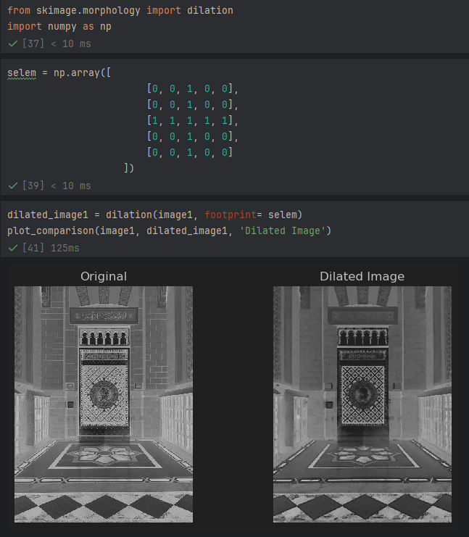

1. Erosion: In this case, default selem (or footprint) was applied to the image as no footprint was specifically identified. The image below shows how erosion affected the image.

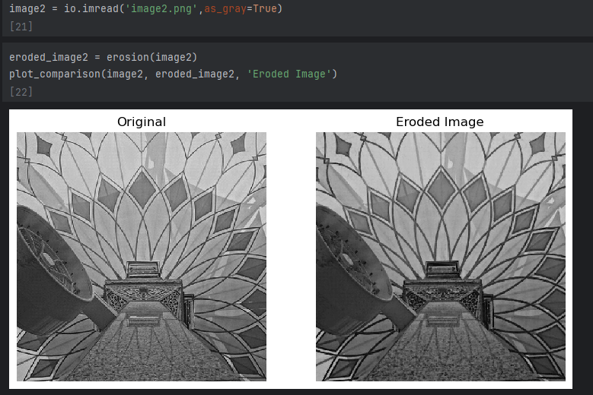

1. Opening: Default footprint used on doing opening which is basically erosion then dilation, results are shown below

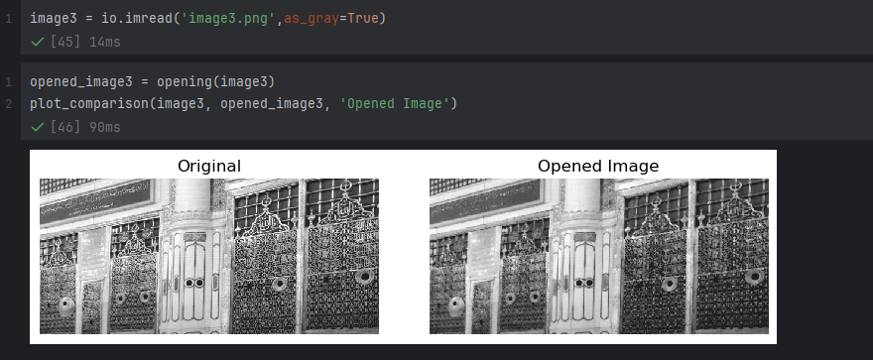

1. Closing: Default footprint used on doing closing function which is basically dilation then erosion, results are shown below

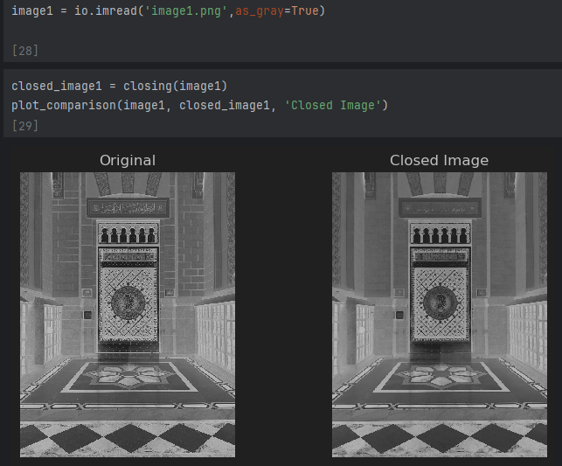

1. Skeletonize: Converting image to binary first then using a default footprint to skeletonize the image, results shown below

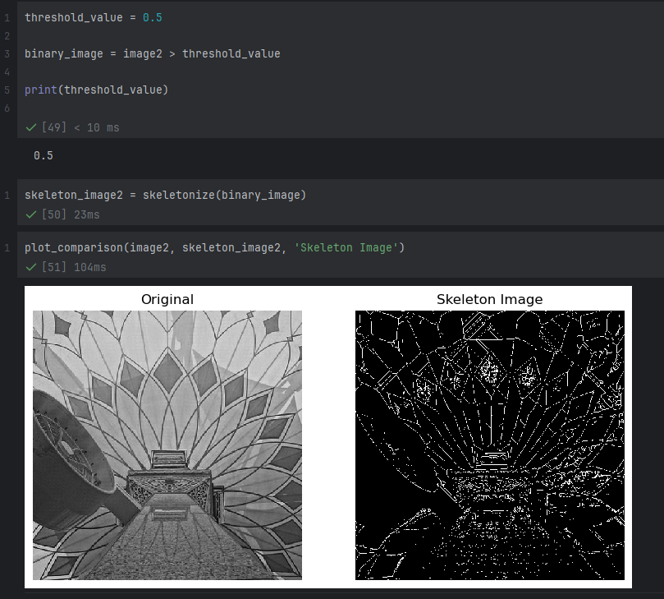

1. Black TopHat: Using default footprint, black tophat which is the original – the result of the closed version of the same image, result is shown below

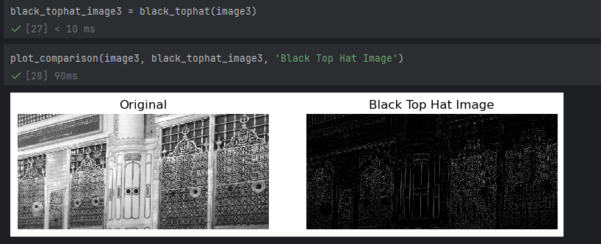

1. White TopHat: Using default footprint, white tophat which is the original – the result of the opening version of the same image, result is shown below

